Using the standard school Rubric
All staff now have access to the STANDARD SET RUBRIC in Turnitin, this will replace the feedback form students used to attach to their submissions. To attach the Rubric to your submission points. This document will show you how to attach it and the mark against it.

Step 1 – Attaching the STANDARD SET RUBRIC

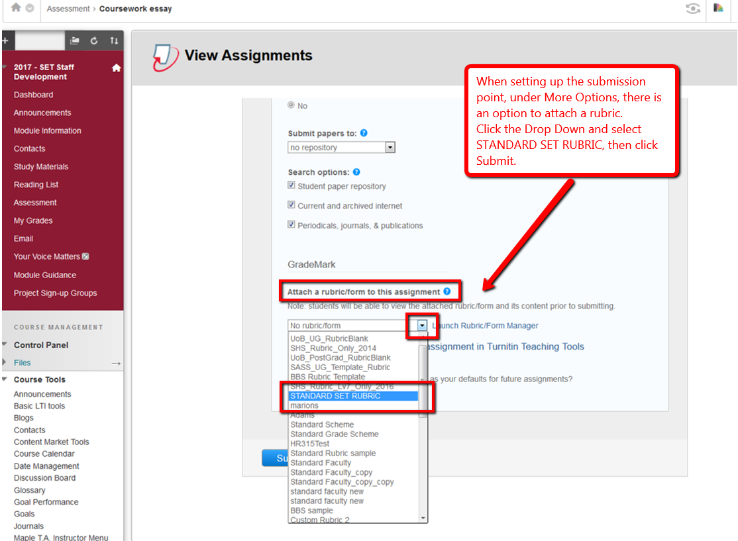

Step 2 – Marking a student paper using the STANDARD SET RUBRIC
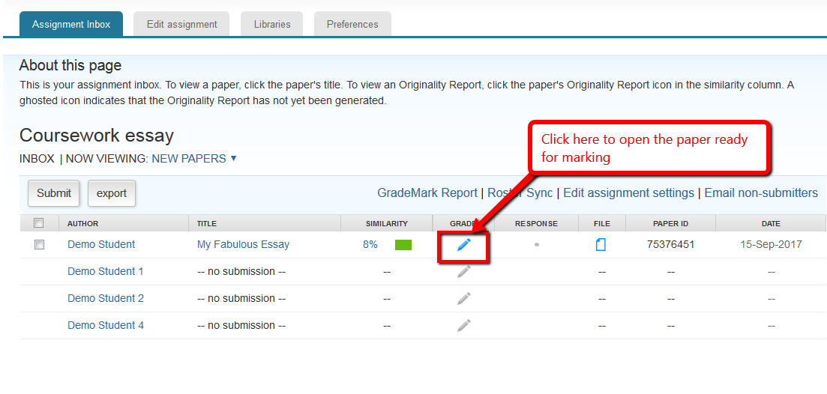
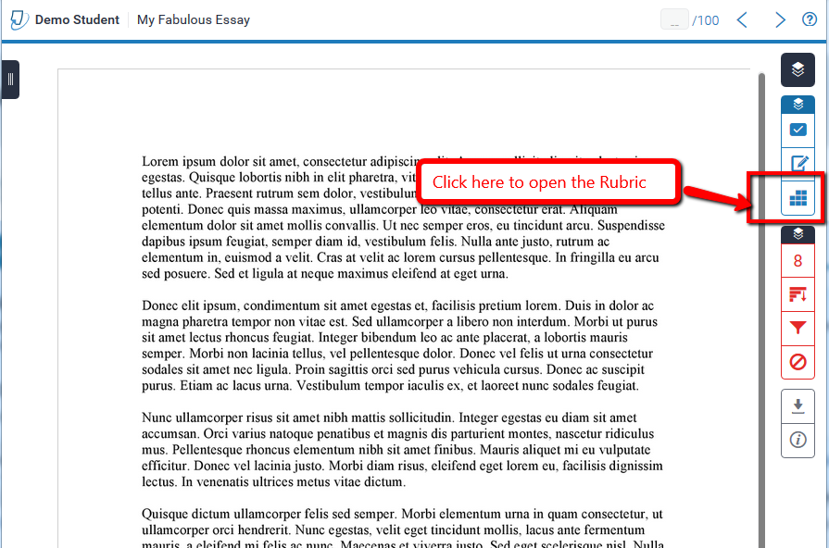
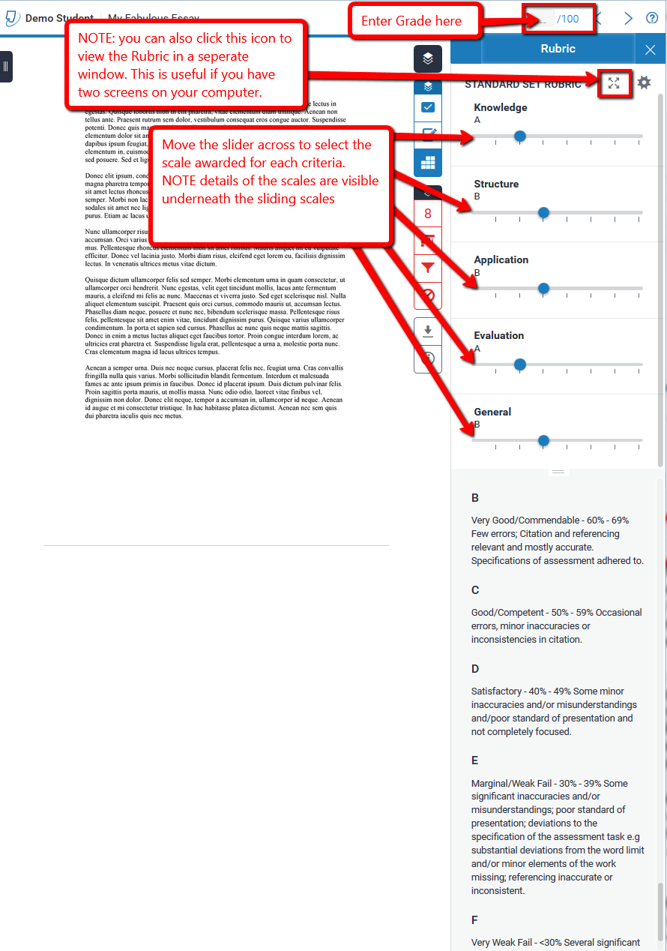

Other Marking Tools

Quick Marks
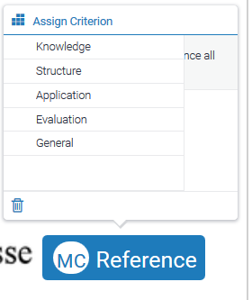
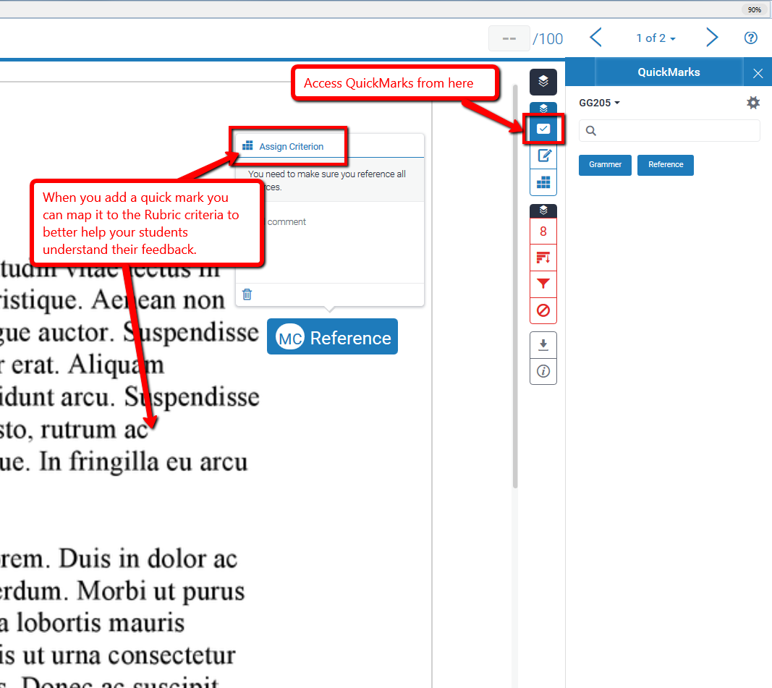

Everything you need to know about Turnitin is available on the IS website, see:
https://staff.brighton.ac.uk/is/learningandteaching/Pages/Turnitin/

