Setting up your Assessment Categories

Creating the categories
- Go to the Full Grade Centre and click on the Manage button and select Categories
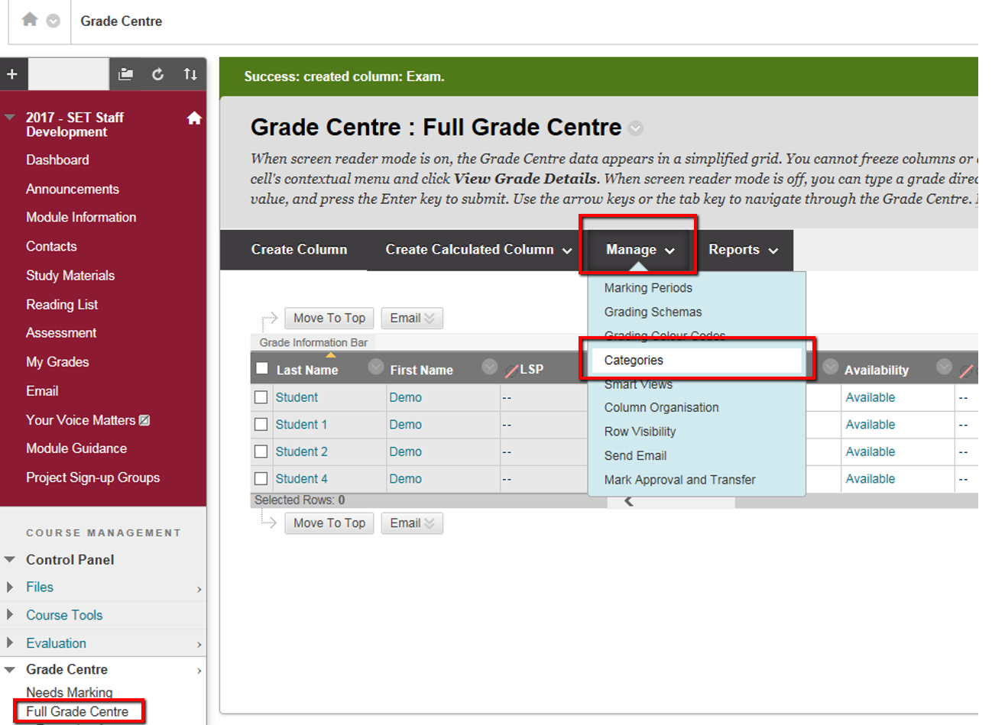
- Click Create Category
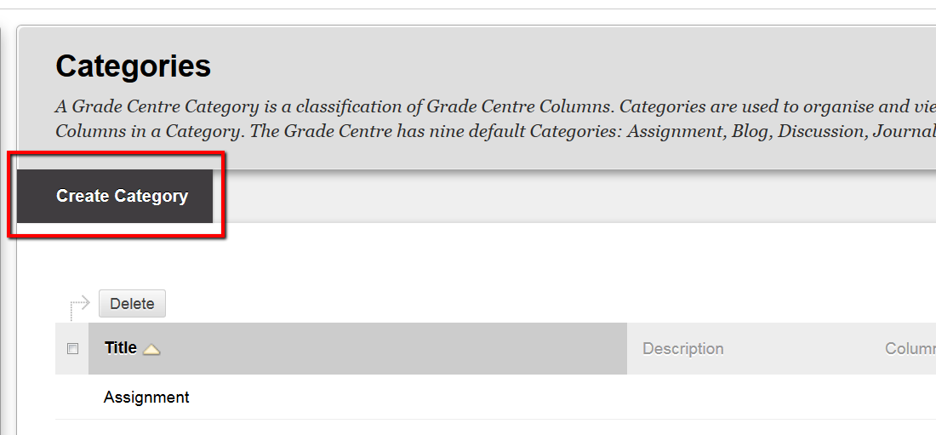
- Enter the name of your category, either Summative Assessment or Formative Assessment, and click submit
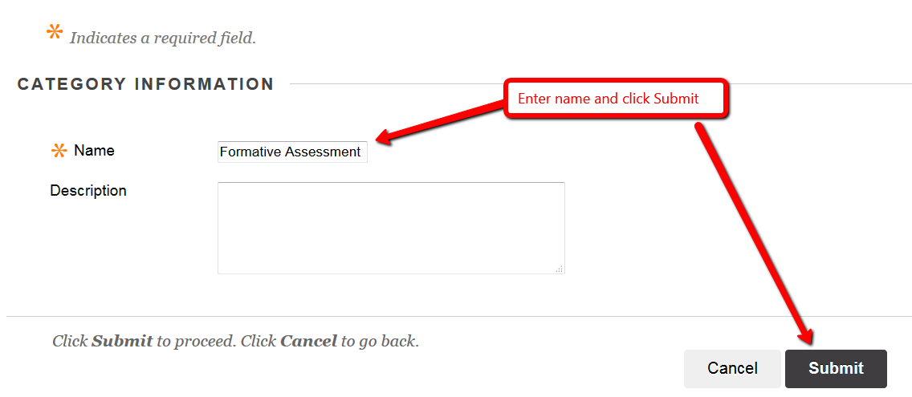

Using the categories
Once you’ve set up your assignment submission points or Grade Centre columns to record Grades then this is how you apply the categories.
- Go to the Full Grade Centre and click on the column heading for the assessment you want to apply the category to.
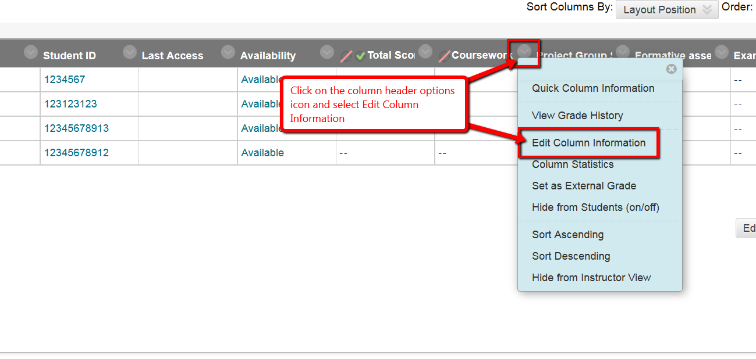
- Locate the Category section, click the drop down available, select either Formative or Summative Assessment and then click the Submit button.
- Repeat for each assessment column on your module.
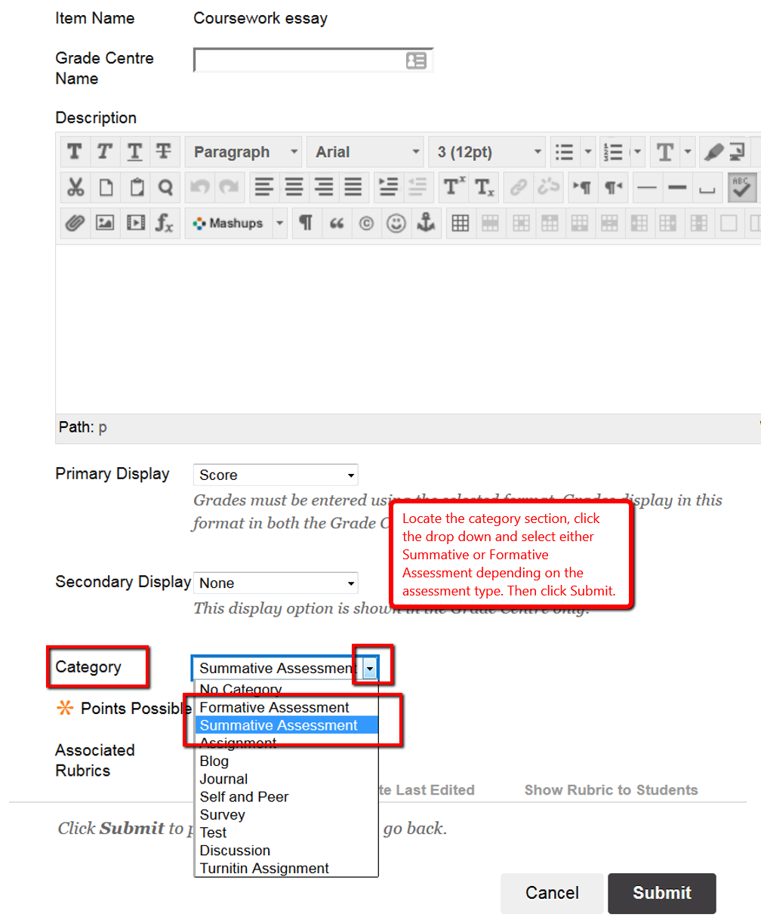

Filtering Categories in your Grade Centre using Smart Views
- Go to the full Grade Centre
- Click Manage and select Smart Views
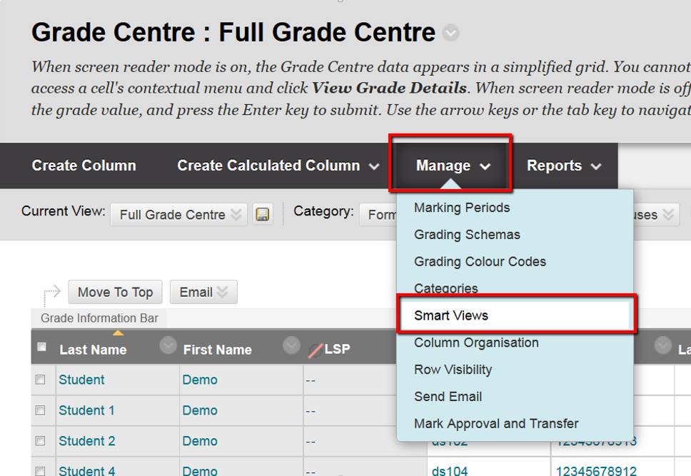
- Click Create Smart View
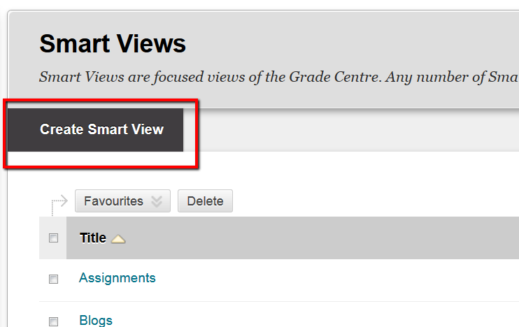
- Enter the details as below, and then repeat the Smart Views process to create the other category filter
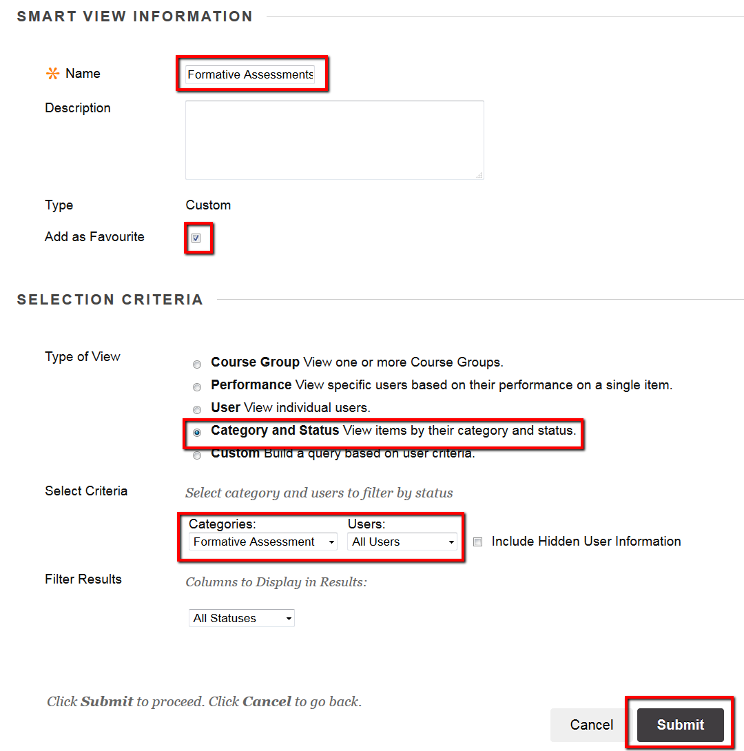
NOTE: You should now see a submenu to your Grade Centre, one for each of the categories you created
