Marking a paper using the studentcentral assignment tool and Rubric.

How to access the assignments
- Go to the relevant module on studentcentral and go to the Grade Centre > Full Grade Centre (if you have groups and smart views set up you can click on the title of your group under the full grade centre)
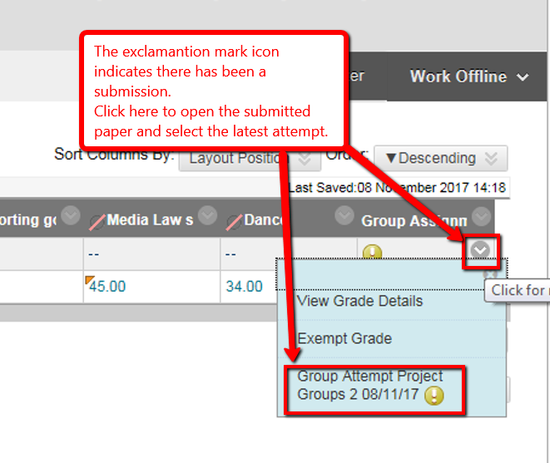
- To access the marking tools see screen shot below.
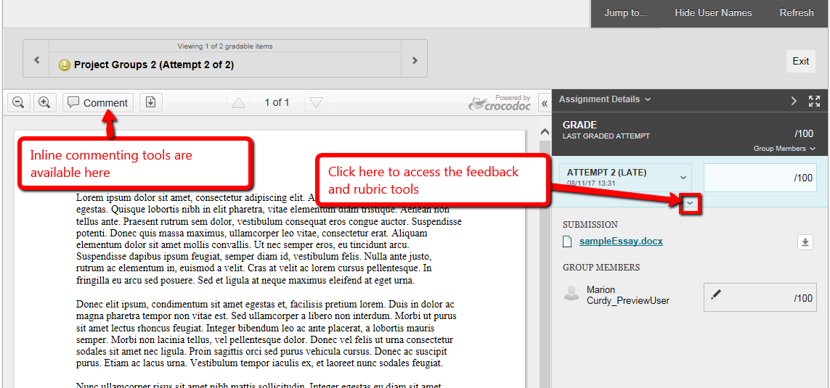
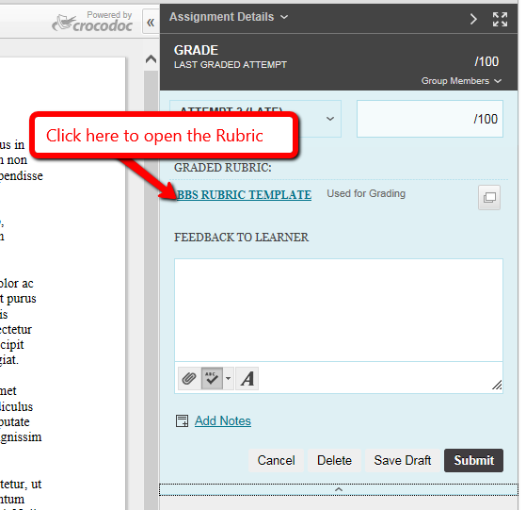
- Note you can choose to display the grade descriptions in the rubric and create a feedback field for each criteria by checking the appropriate boxes (see screen shot)
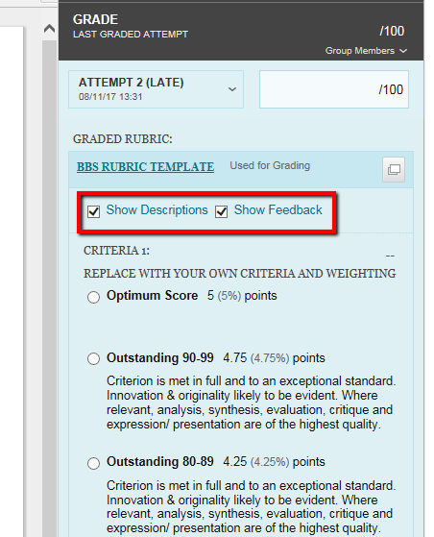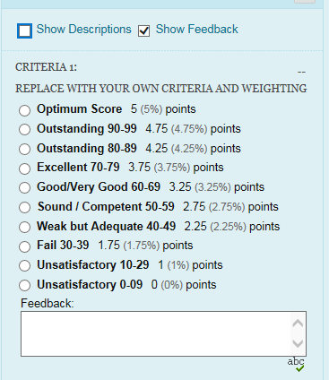
- Before exiting the paper make sure you save both the rubric and the paper.
