Creating the External Examiner Smart View
- Go to the Full grade centre and click on the Manage button and select Smart Views
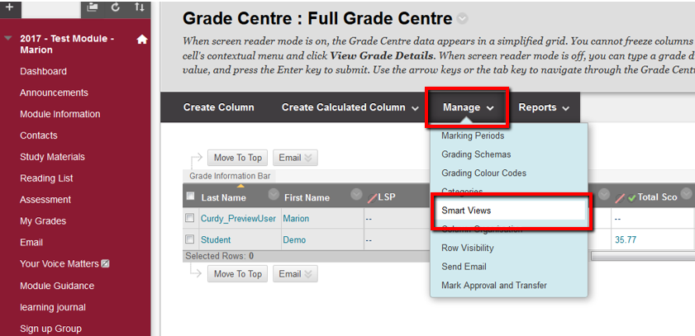
- In the screen that loads you will build the filter, see below for details of what to do.
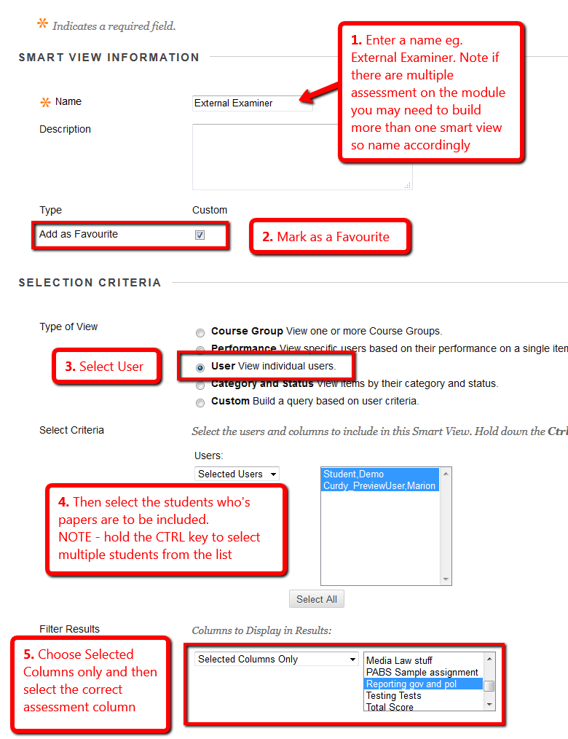
- Click OK.
- You should now see the external examiner link below the full grade centre menu.
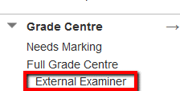
- Repeat this process for each of the assessments you need to give the external examiner access to.

